Transformer-Based Educational Language Model with Deterministic Mathematical Reasoning

ABSTRACT

Problem Statement
Current Large and Small Language Models demonstrate excellent conversational capabilities but often produce mathematically incorrect responses for algorithmic tasks such as arithmetic evaluation, primality testing, factorization, and symbolic manipulation. These errors arise because transformer models learn statistical patterns rather than executing deterministic mathematical algorithms. Although external mathematical tools exist, they are rarely integrated into educational language models developed entirely from scratch. This project proposes the development of a transformer-based educational AI system that combines natural language understanding with a deterministic mathematical runtime to provide accurate mathematical reasoning while maintaining fluent conversational English.

Objectives
The primary objective of this project is to design and implement an educational AI system completely from scratch using modern C++. The project includes the development of a tensor computation library, automatic differentiation engine, neural network framework, tokenizer, transformer architecture, optimizer, training pipeline, and inference engine. Alongside the language model, a deterministic mathematical runtime will be developed to perform exact mathematical computations such as arithmetic operations, prime number testing, factorization, fractions, percentages, ratios, algebraic simplification, and equation solving. The final system should converse naturally in English while delivering accurate and explainable mathematical solutions.

Approach

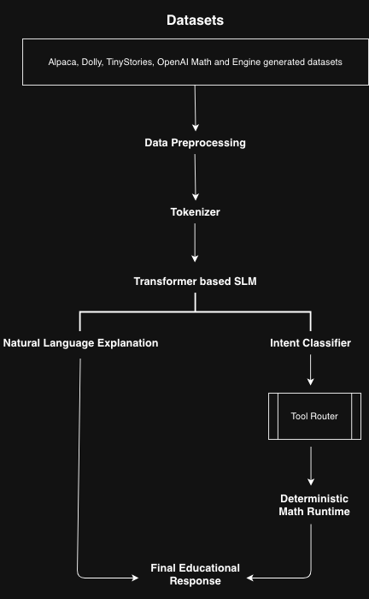

Literature Survey
Transformer architectures such as GPT, LLaMA, Gemma, Qwen, Phi, and SmolLM have significantly advanced natural language processing by demonstrating strong conversational and reasoning abilities. Educational language models have further improved domain-specific learning through instruction tuning and mathematical datasets such as Grade School Math and MathConcepts-Instruct. Recent research has also explored augmenting language models with external computational tools to improve reliability in mathematical and algorithmic tasks. However, most existing implementations rely heavily on deep learning frameworks such as PyTorch and TensorFlow, with limited emphasis on building the complete AI stack or integrating deterministic mathematical runtimes developed from first principles.

Research Gap Identification
Although modern language models generate fluent responses, they remain fundamentally probabilistic systems and frequently make errors in deterministic mathematical computations. Existing solutions generally depend on external APIs or proprietary software, reducing transparency and limiting educational understanding of the complete system architecture. Furthermore, most open-source implementations utilize high-level machine learning frameworks that abstract essential components such as tensor computation, automatic differentiation, and transformer implementation. There exists a need for a fully transparent educational AI system that combines transformer-based language generation with an independently developed deterministic mathematical runtime while implementing every core component from scratch.

Innovation, Creativity, and Novelty
The proposed project introduces a hybrid educational AI system that integrates a transformer-based Small Language Model with a deterministic mathematical runtime. Unlike conventional language models that rely solely on probabilistic reasoning, the proposed system intelligently delegates mathematically verifiable operations—including primality testing, factorization, symbolic manipulation, arithmetic evaluation, fractions, percentages, and algebraic computation—to deterministic algorithms while allowing the transformer to generate natural language explanations. Additionally, the project develops every major AI component independently, including tensor operations, automatic differentiation, tokenizer, transformer architecture, optimizer, and training pipeline, providing complete transparency and educational value.
Feasibility
The project is technically feasible within the proposed timeline through a modular implementation strategy. Individual software components—including the tensor library, automatic differentiation engine, neural network modules, tokenizer, transformer architecture, deterministic mathematical runtime, and training pipeline—will be developed and validated independently before integration. Publicly available datasets will provide conversational and mathematical knowledge, while the symbolic mathematics engine will generate additional domain-specific training data. Cloud GPU platforms may be utilized for model training, enabling practical experimentation without requiring dedicated high-performance hardware.

Datasets

Dataset | URLs
TinyStories | https://huggingface.co/datasets/roneneldan/TinyStories
Alpaca | https://huggingface.co/datasets/tatsu-lab/alpaca
Dolly | https://huggingface.co/datasets/databricks/databricks-dolly-15k
Mathematical Concepts & Tutoring | https://huggingface.co/datasets/kd13/MathConcepts-Instruct-v1
Math Word Problems | https://github.com/openai/grade-school-math

Project Plan
The project will be executed in four major phases. The first phase focuses on developing the tensor library, automatic differentiation engine, neural network framework, and tokenizer. The second phase implements the transformer architecture, optimizer, training pipeline, and inference engine, followed by pretraining on conversational English datasets and instruction tuning. The third phase develops the deterministic mathematical runtime and symbolic mathematics engine capable of performing exact computations and generating procedural mathematical datasets. Finally, the mathematical runtime will be integrated with the transformer through a routing mechanism that selectively delegates algorithmic mathematical tasks while allowing the language model to produce fluent explanations. Comprehensive evaluation, benchmarking, and documentation will be conducted throughout the project to demonstrate measurable monthly progress and validate system performance.

S.No | Student Id | Student Name
1 | 2420030176 | Rochan
2 | 2420090100 | Ansh
3 | 2420090049 | Aryan

Team Members

